# Running for President

It is nearly then end of year and the two main candidates to take over the role of president have been discovered. The players have the choice to choose a scenario to name their player characters for example Hilary Clinton or Donald Trump (Character Customisation). The candidates percentage of votes between the two candidates is too small to take over that they now need to go out and persuade more people to vote for them so then they can become president before there opposing candidate.

The objective of the game is for the players to reach the end of the game board whist collecting enough votes along the way before their opponent so then they can win the game.

# Ruleset

1. Eligible for 2 players
2. Players start at the bottom of the game world
3. Players roll a six sided dice to find out how many spaces they can move. Landing on 1-2 is equivalent to one move 3-4 is two moves and 5-6 is three.
4. All players must land there game piece on the corners of the squares and not inside the square itself.
5. Each square the player lands on them they gain one counter representing one vote. Once a player has landed on the counter they remove it from the game board and keep it. This is known as an internal economy (Adams & Dormans 2012 p60).
6. If any player lands on a corner and there is no counter placed on it they do not get one vote.
7. The players have to collect the same amount or more than the required points to get past the Yellow, Aqua Blue and Orange gates. The yellow gate requires eight points, aqua blue requires 20 points and orange requires 40 points. All collectable counters are colour coded to their section on the game board.
8. Once players go past each boundary on the game board they cannot go back to the previous section they came from.
9. If one player lands on another player space whist they are on it they have to roll a die once each and whoever has the largest number shown drains two votes away from the losing player’s collected votes (Adams & Dormans 2012 pp140-142).

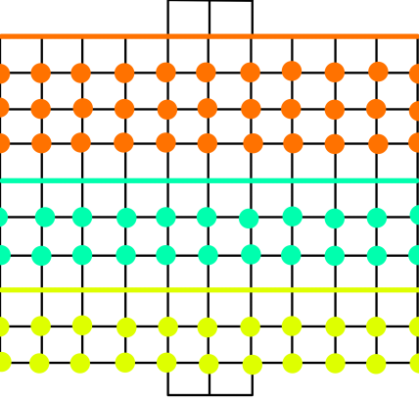

# Game world

The game board shown in figure 1 is a 12x11 board and the players start at the bottom of the game board.

The yellow, aqua blue and orange lines represent one of the core mechanics called regional gating (Hauteville 2011) / lock and key system (Adams & Dormans 2012 pp247-250).This is where the player needs to collect enough votes in order to pass the coloured lines and gain access to the next part of the board.

Figure 1

# Game contents

1. One game board sized 31cm x 29.7cm
2. 30 yellow counters ( 22 for game board, 8 spare)
3. 30 blue counters ( 22 for the game board, 8 spare)
4. 40 orange counters ( 33 for game board, 7 spare)
5. 6 different coloured player pieces ( only two or less to be used each game)
6. 1 six sided die

# Game Mechanics, Play Tests & Iterations

After creating my game board and the game pieces, I then got some friends, fellow students and family to play test the game. Whist I was observing the people playing the game I made notes on how to improve the game as well as taking advice from the players themselves.

When the players first start and get lucky with their roll dice whereas their opponent does not the luckier player is able to collect the available counters/ votes a lot quicker than their opponent, causing them to quit the game. This happens because this game mechanic relies of chance rather than strategy. I then changed this so then the game would not being ruined over blind luck and add more strategy, so my first iteration to my game is to remove the dice rolling mechanic for player moves and replace it with the option for the players to choose their movement strategies before the game starts. The players have the option of moving up/down two spaces and one space left/right or one space up/down and two spaces left/right (Character Customisation). Using this new rule made both players think what strategy to use before the game even starts and throughout the game. This then made the games player movement not rely on chance (Adams 2010 p325).

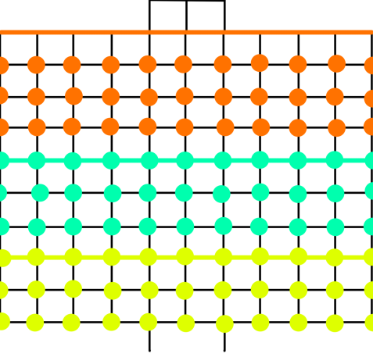Once this new rule was added to the game ruleset on some occasions both players movement was limited due to not having the space to move there piece. So my next iteration is to add one whole column of counters colour coded to their boundaries except the orange section. This is shown in figure two. Adding this then allowed the players to use there chosen way of movement more effectively, but I then noticed there would not be enough counters to make this rule so I had to change the game contents to the below.

1. One game board sized 31cm x 29.7cm
2. 40 yellow counters ( 33 for game board, 7 spare)
3. 40 blue counters ( 33 for the game board, 7 spare)
4. 40 orange counters ( 33 for game board, 7 spare)
5. 6 different coloured player pieces
6. 1 six sided die

Figure 2

Once I added the previous rule to the game and got people to play-test the game once again, once they started to collect a considerable amount of counters they noticed that all three coloured counters have the same value of votes, therefore the votes system isn’t really an internal economy. So I increased the values of votes for all three coloured counters. Yellow counters are valued as one vote, blue as two and orange as three. Once I iterated this, the value of votes required to get past the boundaries became very easy and was ineffective towards gameplay. I changed this by increasing the values of all the board boundaries for both players so then they were high enough to challenge the players. I kept the yellow boundary the same, changed the blue boundary to 30 and orange boundary to 70 votes (Hauteville 2011).

When the players got enough counters to get past the boundaries, I noticed that both players didn’t need to attack each other because there where more than enough counters for both players to collect on the game board. This turned the game into a race to the top of the board without the need to interfere with one another which defeated the point of the game. I iterated this rule by further increasing the boundaries required to progress through the game. I changed the yellow boundaries votes’ requirement to 20, blue boundary to 60 and orange boundary to 110 votes (Adams & Dormans 2012 pp247-250).

Once I added the previous iteration to the game board both players realised there isn’t enough collectable votes to progress through the game so both players where encountering each other a lot more often. As the both players progressed they noticed that winning an encounter’s incentive wasn’t enough and made little difference towards the required votes to get past the boundaries/ win the game. I therefore further iterated the player encounter rule by changing the encounter winning rewards to one vote for the yellow section, four votes for the blue and six for the orange (Shell 2008 p177). The winning player then drains the votes from the losing player’s total votes (Drained)

Once I iterated this rule the players where encouraged more to attack there opponent for more votes. As the play-test went on the players encountered a problem. When one of the players pass one of the boundaries, leaving the opponent on the previous section of the board the opponent has very little to no further counters’ to collect votes causing the player to be in an deadlock situation and not being able to progress (Adams & Dormans 2012 p69) though the game showing the games positive feedback isn’t great (Adams 2010 pp350-351).

To stop this from happening I introduced a grinding mechanic to the game (Adams 2010 p325). In this new mechanic I’ll use to fix the deadlock situation by replenishing all the counters taken by both players after one of them progressed to the next section and has had two moves (Levelling up system). Before that happens any counters collected by the player falling behind is worth double the amount of the initial votes it’s valued as. This made it easier for the loosing player to collect the votes needed to pass through to the next section and catch up with their opponent. After adding this new mechanic the amount of counters in the current game contents had not been enough so I had to iterate the game contents. The new game contents are shown below.

1. One game board sized 31cm x 29.7cm
2. 80 yellow counters ( 66 for game board, 14 spare)
3. 80 blue counters ( 66 for the game board, 14 spare)
4. 80 orange counters ( 66 for game board, 14 spare)
5. 6 different coloured player pieces ( only two or less to be used each game)
6. 1 six sided die

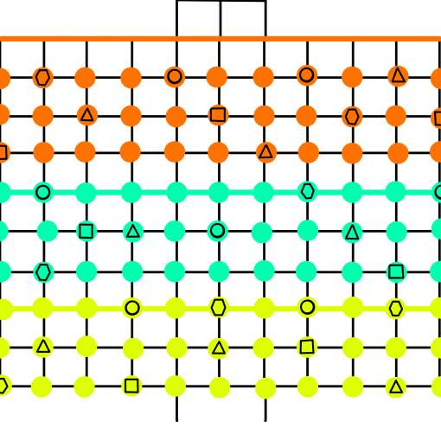After adding this new grinding mechanic to the game board the players started to get bored with just collecting counters so I’ve decided to add special landing zones for the players to land on and get a bonus. This is much like the well-known game scrabble. These bonuses are hidden underneath the counters and can be used when the player lands on the counter and removes it from the game. These bonuses can be good or bad. The available bonuses are shown below (Character Upgrade).

1. An extra move to the up/down moves (Triangle)
2. An extra move to the left right moves (Square)
3. Minus an move to the left/right (Circle)
4. Minus an move to the up/down moves (Hexagon)

Figure 3

When I added this new rule the game it added a little more tension and strategy between the players so they can get the bonuses. This is shown on figure 3

Now that I’ve added/ iterated the ruleset the game flowed and soon there was a winner. Once one player won they wanted to play again so what I decided to do is to include a reward for the winning player before starting the next game. so what I did was to give the winning player from the previous game six votes to start with, this included one yellow, blue and orange counter.

# Bibliography

Hauteville, C. (2011). *Gating.* Available: <https://goo.gl/cxO1oq>. (Last accessed 3rd Jan 2017 ).

Adams, E & Dormans, J. (2012). Common Mechanisms. In: Johnson, J & Wimpsett, T *Game Mechanics Advanced Game Design*. United States: New Riders. p140-142.

Adams, E & Dormans, J. (2012).Internal Economy. In: Johnson, J & Wimpsett, T *Game Mechanics Advanced Game Design*. United States: New Riders. p60-69.

Adams, E & Dormans, J. (2012).Progression Mechanisms. In: Johnson, J & Wimpsett, T *Game Mechanics Advanced Game Design*. United States: New Riders. p247-257

Adams, E. (2010). Game Balancing. In: Adams, E *Fundamentals of Games Design*. 2nd ed. United States: New Riders. p324-326.

Schell, J. (2008). Game Mechanics Must be in Balance. In: Morgan Kaufmann *The Art of Games Design*. Burlinton: Elsevier. p171-180

Adams, E. (2010). Game Balancing. In: Adams, E *Fundamentals of Games Design*. 2nd ed. United States: New Riders. p349-351.